Gladius Desktop Client on Docker Toolbox running on Windows 7

Hello All

This is an early exposure of the Gladius Desktop Client running on Docker Toolbox on Windows 7. Took a little bit of work but with the help of Alex at Gladius I got it to work. Very promising platform.

The file for download is an OVF file for virtualization.

User: gladius Pass: gladiuspw

root password is also gladiuspw

The IP address is configured to be static. You can change the network interface setup to suite your purpose.

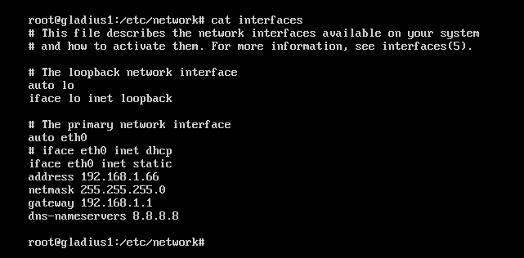

Upon boot up login. Then change to the gladius-node-client folder.

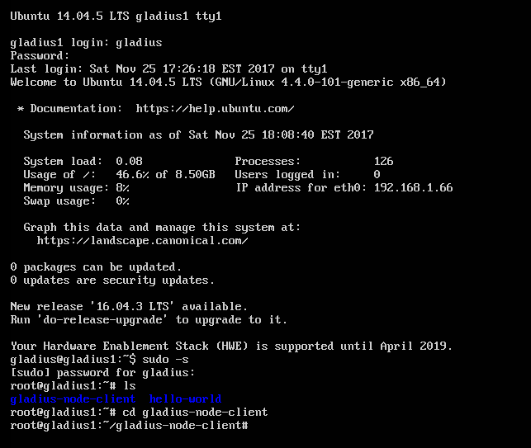

Now start the Docker platform.

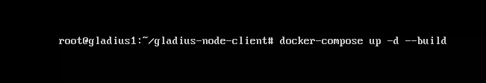

The first time you run this it will take about five minutes if you are setting it up yourself. However, now that it has been run once running this now will now take a few seconds.

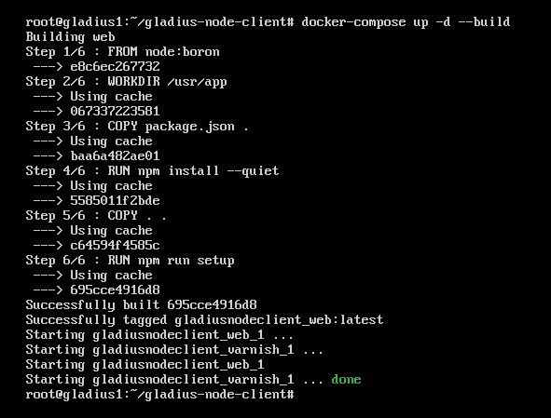

I had to do this next step initially with the new setup but you should not have to. I include it just in case and for your additional knowledge. There was a bug in the current Gladius Desktop Client that Alex shared with me and the following steps are the fix in case you are setting this up from scratch on your own. Once the Docker instance is running you need to do an additional step within the Docker instance itself. First you need to identify the Docker instance with the following command.

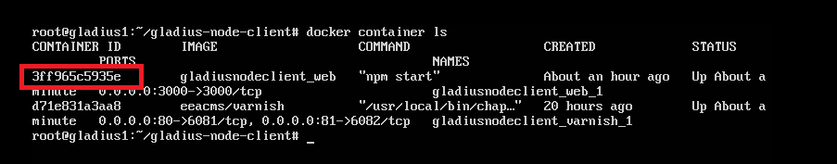

The above command will identify the Docker instance for Gladius. Then you need to BASH into the Docker instance. Every time you start a new instance of Docker for Gladius it will have a new Docker ID. You will use that Docker instance ID in the next command.

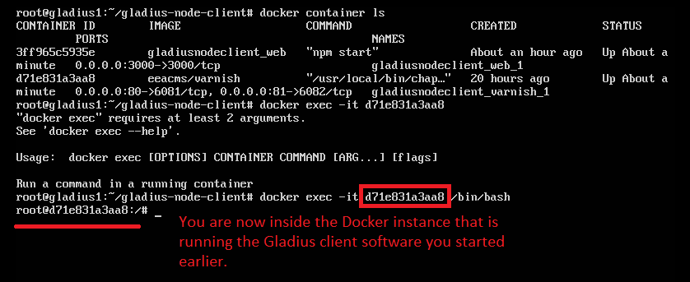

This is only necessary if you are setting up for the first time. Evidently it is as a result of a bug in the current version of the Gladius Desktop Client. Significant improvements are going to be made in the next versions and eventually Docker will not be included. But I wanted everyone to see the progress that Gladius is making on this initiative so I invested some time to create an easily implemented working version. The Gladius Team is still working on a Mining Pool but that will come soon. My goal is to have my own mining pool in my datacenter.

So anyway, this command seems to only have to be run once within the Gladius Docker Instance.



Once that is done you should be able to open a web browser.

<http://192.168.1.66:3000/>

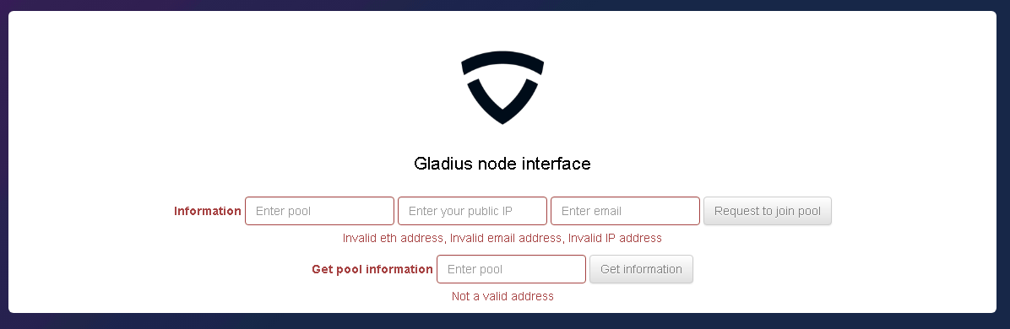

Soon the Gladius team will have some Mining Pools setup so that you can use the Gladius Desktop Client. I also plan to setup my own Gladius Mining pool so others can use it.

I look forward to the success of Gladius.

Arnold Villeneuve